Marshfield Agricultural and Horticultural Society Celebrates America

The Marshfield Agricultural and Horticultural Society is celebrating the 250th anniversary of America with special events throughout the 10 days of the Marshfield Fair being held August 21 – 30, 2026.

The quilting department will be honoring our veterans by awarding Quilts of Valor made by area quilting guilds to local veterans. These Quilts of Valor are formally awarded to a Service Member or Veteran touched by war, serving as a tangible "thank you" for their service and sacrifice. Intended to provide comfort and healing, these quilts are civilian awards registered through the Quilts of Valor Foundation.
A special ceremony will be held on Sunday, August 30 at 1:00 pm. Veteran’s Day at Marshfield Fair will also be Sunday, August 30. Any Veteran or Active Duty Service member with proper identification
will receive free admission on August 30.
Other special events include commenerative themed contests in 4-H, agriculture, arts and crafts, baking, horticulture and photography as well as music, demonstations, exhibits and entertainment designed to honor the nation’s semiquincentenial.

In addition to the national celebrations, the Marshfield Agricultural and Horticultural Society is using this milestone to celebrate the memory and legacy of two past directors who recently passed away.

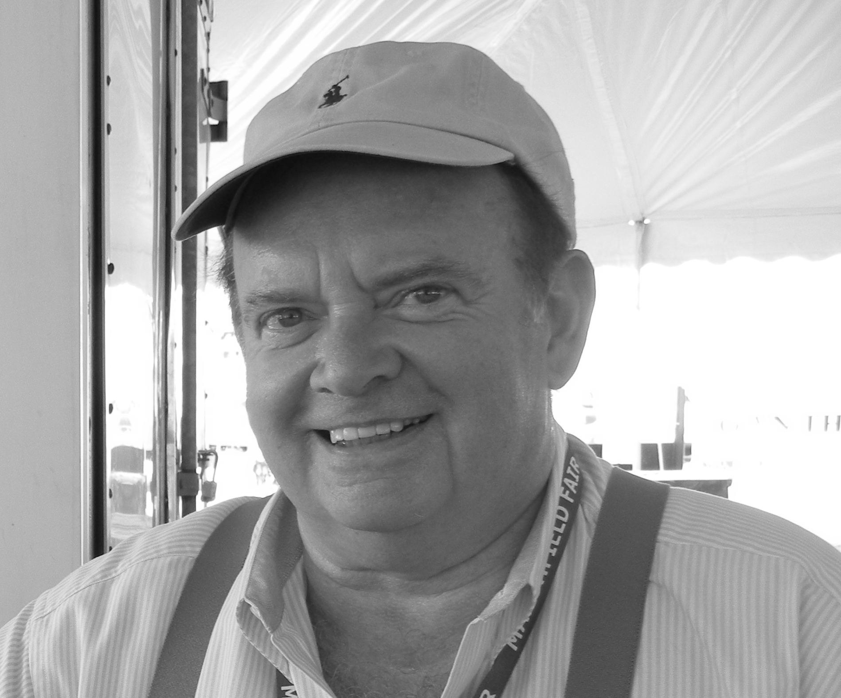
William F. Last, Sr.
Billy’s dedication to the community and his family carried over to his role as a director of the Marshfield Agricultural and Horticultural Society. He served on the entertainment committee, was in charge of Children’s Day and Senior Day activities, was instrumental in booking and managing musical acts and bringing new ideas to the Marshfield Fair, and was always ready to step in when something needed to be done.


Gerald K. Covey
Gerry proudly served 24 years in the United States Air Force. Following his military service, he became an Air Force recruiter until his retirement in 1978. As a director, his primary responsibility centered on organizing, managing, and executing the fair’s special events, ensuring entertainment and community activities ran smoothly each year.

`
Admission: $15.00
Children Ages 6 & Under Free
Marshfield Days - Friday, August 21 & 28
Senior Citizen Day - Tuesday, August 25
4H & Agriculture Awareness Day - Wednesday, August 26
Children's Day - Thursday, August 27
Veteran’s Day - Sunday, August 30

Midway - 4-H Livestock Shows
Fruit, Vegetable & Flower Exhibits & Shows
Agriculture & Conservation Displays - Giant Pumpkins
Standard Flower Show
Model Railroad - Bee Exhibits
Horse Competitions and Demonstrations
Rabbit Display
Arts & Crafts
Quilting

2026 MARSHFIELD FAIR
Route 3A, Marshfield, Massachusetts
Friday, August 21 - Sunday, August 30
Every Day from 12 noon - 10 pm
Continuous Family Entertainment
Special Features Nightly
Discounted Advance Sale Tickets Available
Online Tickets Available
For more information, call 781-834-6629
www.marshfieldfair.org

Officers & Directors & Departments 5
TABLE OF CONTENTS
Plymouth County Extension 5
Marshfield Fair Celebrates America and Shows 6
Exhibits 7
Lectures, Workshops and Demonstration Schedule 7
Scholarships 8
Country Arts Awards 8
Exhibitor's Entry Dates & Times 8
Exhibitor's Rules & Regulations 9
Country Arts Exhibit Rules 9
Craft Shop 10
Quilt Block Contests 11
John LaForest Bird Carving Contest 11
Baking Contests 12
Quilts of Valor 12
Departments 121-123 (Country Arts) 13-17
Country Arts Entry Form 18
Photography 19-20
Horticulture Special Awards, Contests & Exhibits 21
GCFMA Standard Flower Show 21
Horticulture Entry Rules & Contests 22-25
Horticulture Entry Form 25
Agriculture Special Contests 26
Giant Pumpkin Contests 26
Agriculture Entry Rules 27
Egg Show 27
Apiary 27
Agricultural Exhibits 28
Vegetables Contests 29-30
Fruits 30
Giant Vegetable Contest 30
Canned Goods 31
Agriculture Entry Form 32 Animal Online Entry Information 33
Animal Health Rules 34
Marshfield Fair 4-H and Youth General Rules 35
4-H and Youth Shows Code of Conduct 36
4-H and Youth Livestock Schedule 37
4-H Day Activities 37
Marshfield Fair 4-H and Youth Animal Contests 38-40
Animal Entry Form 41
Dog Agility & Dog Exhibit & Entry Form 42-43
Dog Show and Entry Form 44-45
Marshfield Fair 4-H and Youth Achievement 46
Achievement Entry Form 47
Poultry 48-49
Marshfield Fair 4-H Awards 50
Pulling Contests 51
Presale Tickets 51

FREE Children’s Activities
Milking Cow Farmer for a While
The Zoo Show
Scavenger Hunt
Children’s Zoo Model Railroad
PLYMOUTH COUNTY
COOPERATIVE EXTENSION
MARSHFIELD AGRICULTURAL
&
HORTICULTURAL SOCIETY

2026 OFFICERS
Leonard S. LaForest President
Janet Scribner Vice President
Carleton E. Chandler Secretary/Treasurer
Todd Goodwin Auditor

DIRECTORS
Carleton Chandler Jeff Chandler Richard Ingham Todd Goodwin Veronica Lahage Leonard LaForest David McDougall Noel Powers Janet Scribner Joseph Tamulis Chris Villano Colby Vining

HONOARARY DIRECTORS
Stephanie Baker Bridget Burns
Priscilla Chandler David Connor
Robert DeCastro William Frugoli
Frank Hartnett Andrew Park
Linda Taddia

EXECUTIVE MANAGEMENT COMMITTEE
Carleton E. Chandler Richard Ingham
Leonard S. LaForest David McDougall
Janet Scribner Colby Vining

MARSHFIELD FAIR DEPARTMENTS
General Operations Carleton E. Chandler
Special Events, Hospitality Stacey Reisman
Concessions Leonard LaForest, Noel Powers,
David McDougall
Public Relations & Marketing Janet Scribner
Sponsorships Noel Powers
Entertainment, Grounds David McDougall
Arts & Crafts Stephanie Fariello
Accounting Kaileigh Jarvis
Agriculture Priscilla Chandler, Laurie Wheeler
Horticulture Veronica Lahage
4-H Jeff Chandler
Exhibitor Entry Linda Taddia
Chief of Security Jamie Connor
First Aid Meg Needham
Grounds, Parking Joseph Tamulis
Grounds Maintenance Ken Roderick
Building/Ground Maintenance Richard Ingham
Plumber Jeff Hubbard
Electrician Chris Villano
Photography Exhibit Grace Taylor
Quilt Contest Pam White, Laurie DeCastro
Country Arts Shop Sara Thurber
Fair Museum Steve DeCastro, Joe Tamulis
Assistant Grounds Manager Colby Vining
Souvenir Shop Chrissy McDougall
Entertainment Andrew Parks

Plymouth County Extension is part of the UMass Extension System in cooperation with USDA and Plymouth County government. Extension is a national network which conducts research and educates people so they can improve the quality of life. Extension educators, including trained volunteers, teach individuals and groups throughout the commonwealth to solve problems, develop capabilities and invest in the future.
Plymouth County Extension Programs
Molly Vollmer – Extension Director
Blake Dinius - Extension Entomologist
Cathy Acampora – 4-H Extension Educator
Cheryl Mechan – Administrative Assistant
Meghan Riley – Agricultural Extension Educator
Plymouth County Extension Office
44 Obery Street
Plymouth, Ma 02360
774-404-7020 (phone)
774-773-3184(fax)
www.plymouthcounty4h.org
mvollmer@umext.umass.edu

Plymouth County Commissioners:
Gregory M. Hanley - Plymouth
Jared L. Valanzola – Chairman, Rockland
Sandra Wright - Bridgewater
For information about other 4-H programs contact:
Central MA Region 508-831-1223
Northeast MA Region 617-243-1931
Southeast MA Region 508-831-1223
Western Ma Region 413-545-2646
Barnstable County 508-375-6696
For information on “joining 4-H”
call your local office or www.mass4h.org on the web.
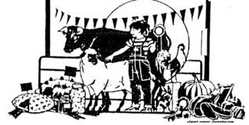
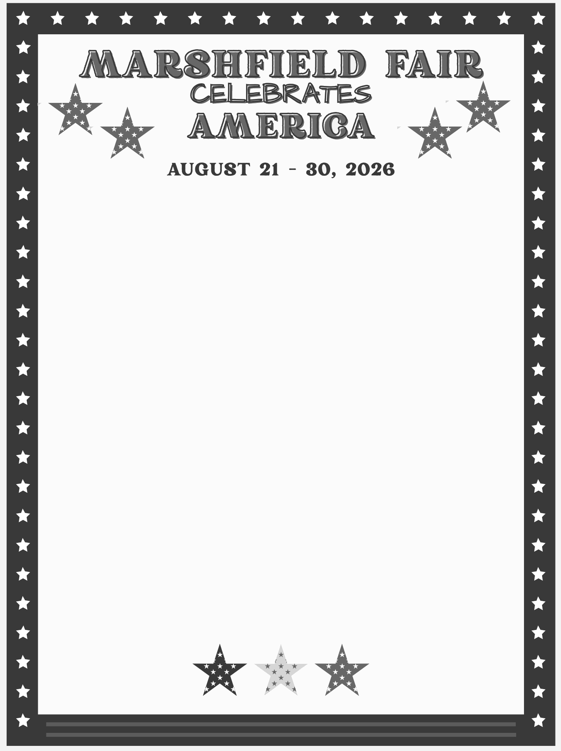
4-H Celebrates America
2026 Educational Poster theme Animals in American History
4-H Celebrates America throughout the week in many different ways.
Agriculture Celebrates America
250 years of Agriculture in the United States - Agriculture Educational Exhibits (pg. 28)
Scary Qinn Centennial - Patriotic Scarecrow (pg. 30)
Charcuterie Contest - Red, White and Blue and American BBQ (pg.26)

Arts & Crafts Celebrates America
Cooking Contest – American Pie and Cookout Foods (pg. 12)
Country Arts invites you to showcase your creativity with work inspired by the colors, culture, traditions, and symbols that make our country unique. Enter crafts in any of our categories incorporating “red, white, and blue”, patriotic imagery, Americana style or personal interpretation of what America means to you.” Special ribbons awarded.

Horticulture Celebrates America
Prizes As Listed in Department
Historic Farms - Amateur Garden Exhibit (pg. 22)
America’s 250th - Small Space Container Garden (pg. 22)
Early Americana - Mantel Contest (pg. 22)
Celebrating American Ingenuity - Floral Arrangement or Potted Plant (pg. 22)
Paul Revere’s Lantern - Fresh Floral Arrangement (pg. 23)
Photography Celebrates America
Photography - Photograph Depicting America the Beautiful
Quilting
The awarding of Quilts of Valor celebrating our local veterans/heroes (pg. 12)
Presentation on Sunday, August 30 at 1:00 pm.
Notes to Veterans (Arts & Crafts and Agriculture)

EXHIBITS & SHOWS
Fri, Aug. 21 All Day GCFM Standard Flower Show
12:30 Dog Show
1-6 Ox Pulling
4:00 Rabbit Achievement
Sat, Aug. 22 12:00 Cattle Sorting
12:30 Poultry Achievement
1:00 Baking & Cooking
N. E. Giant Pumpkin Contest
3:30 Beef Achievement
5:00 Jr. Pumpkin Contest
6:30 Dog Performance
Sun, Aug.23 12:00 Cattle Sorting
12:30 Sheep Achievement
2:00 Hydrangea Show
Charcuterie Vegetable Contest
4:00 Dairy Cattle Achievement
Mon, Aug. 24 12:30 Dairy Goat Show
5:00 Swine Achievement
Tues, Aug. 25 12:30 Dairy Goat Achievement
2:00 Open Sunflower Show
5:30 Swine Show
Wed, Aug. 26 All Day Ikebana in Horticulture
All Day 4-H & Youth Activities
4:00 Appetizer Plate Contest

Thu, Aug. 27 12:30 Rabbit Show
1 - 6 Horse Pulling
2:00 Zinnia Contest
6:30 Dog Agility Show
Fri, Aug. 28 12:30 Dog Achievement
Horse Show - Ag Ring
2:00 Horse Achievement - Ag Ring
Meet the Dog Breeds
4:30 Dairy Cattle Show
Horse Vaulting
7:00 4-H Talent Show

Sat, Aug. 29 12:00 Bird Carving Contest
12:30 Sheep Show
1:00 Baking & Cooking
2:00 Charcuterie Vegetable Contest
4:30 Beef Cattle Show
5:30 Livestock Over the Hill Class
6:00 4-H Alumni Class
Sun, Aug. 30 12-6 Antique Truck & Tractor Show
12:30 4-H Quiz Bowl
1:00 Quilt of Valor Ceremony
2:00 Horticulture Awards
4:00 4-H Fair Awards
Plant Auction - Horticulture
SPECIAL EVENTS

LECTURES, WORKSHOPS & DEMONSTRATIONS
Horticulture
Downstairs in Agricultural Hall
BUTTERFLIES All 10 Days!
Aug. 21 Noon GCFM Standard Flower Show
Butterflies here for 10 days
Aug. 22 2:00 Plant ID Apps & Tech – Nick Lahage
4:00 Learn about Sogetsu/Ikebana – Nefertiti SanMiguel
Aug. 23 11:30 Enter Hydrangea Show judged @2pm
4:00 All about Native Plants–Kristen of Blue Stem Natives
Aug. 24 2:00 Butterfly Plants & Plans
4:00 Hydrangea 101 – Roni Lahage
Aug. 25 11:30 Enter Sunflower Contest judged @1
2:00 Growing Sunflowers with Bill Carpenter
Aug. 26 2:00 Tour new Ikebana Show
4:00 Biodiversity in the Garden–Ann McGovern
Aug. 27 2:00 Raised Bed Planting Demo – Dana Shaw 3-5 Kids Activity
Aug. 28 2:00 Butterfly Plants & Plans 4:00 Tour the Herb Garden, Q & A
Aug. 29 12:00 Get your tickets ($2) for Wine Tasting
2:00 Garden Journaling with Martha Himes
5:00 Wine Tasting, 50 seats only!
Aug. 30 2:00 Excellence & Popular Choice Awards
4:00 Plant Auction
6:00 Butterflies Go Free!

Arts & Crafts
Main Floor Agricultural Hall
Aug. 21 12-4 Painting – Dylan Lamphere
Aug. 22 12-4 Painting – Dottie Perotti
Aug. 23 12-4 Collage – Mandy Fariello
Aug. 24 12-4 Oil Painting – Jody Regan
Aug. 25 12-4 Chair Caning and Rushwork
by Erin & John Matthews
Aug. 26 12-4 Hooked Rugs
Aug.27 12-4 Needlework – Carol DiFazio, Carol
Walsh & Miriam Rosa
12-4 Mug Rug Quilt – Make and Take
Aug. 28 12-4 Nantucket Baskets - Janice Card
Agriculture
Daily at 3 under the Grandstand
Organic Gardening
Daily at 3:00 with Rick Madden – Next to Horticulture
Ham Radio Exhibit
Daily at 3 & 6 - Intro to Ham Radio, How to get on Air
next to First Aid/Security
Woodturners
Daily at 1- 6 – Demonstrations - next to First Aid
SCHOLARSHIPS & AWARDS

Marshfield Agricultural and Horticultural Society
initiated a Scholarship Program in 1982. These scholarships are awarded annually to graduates of
Marshfield High School. Preference will be given to a Marshfield High School student furthering his or her
education in agricultural and horticultural studies, aquaculture, marine biology, conservation, forestry
or other related fields.
Marshfield Agricultural & Horticultural Scholarships

Marshfield Agricultural and Horticultural Society
awards five scholarships in the amount
of $1,000.00 each.
The 2025 and 2026 recipients were:
2025 – Riley Abell, William Jones,
Liliano Minchello, Coltan Spano, Anna Sullivan
2026 - Nathan Boshans, Liam Deane,
Brooke Kelly, Julie Pozerski, Patrick Sullivan
The Society also provides scholarships of $1,000
each to a deserving student from Bristol County Agricultural School and Norfolk County
Agricultural School.
Dean & Flynn Fiesta Show Scholarships

The Dean & Flynn Fiesta Show Scholarship
awards are given in memory of Mrs. Lillian Dean.
Five $ 1,000 scholarships were given to:
2025 – Ainsley Dunn, Ryan Hay, Jack Kenney,
Joseph Rotundo, Taylor Twomey
2026 - Caroline Commesso, Isabel Foley,
Nolan Keeler, Mia LoVuolo, Brendan McLaughlin
Marshfield Fair 4-H Awards

The Marshfield Fair 4-H awards are for 4-H members
who meet the award qualifications. Award nomination deadline is Thurs. Aug 27@ 6 pm. For a listing and
complete description, go to marshfieldfair.org.

COUNTRY ARTS AWARDS
In 2001, long-time Marshfield Fair Director John LaForest passed away. After retiring, John became an avid bird carver who produced over
100 carvings, giving many as gifts and donating many to charity auctions. Those who are lucky to have one of John's carvings realize they
own something special. For many years John also exhibited his carvings at the Fair and demonstrated carving in the exhibit hall. It was always John's wish to develop a larger bird carving presence at the Marshfield Fair. In his honor, in 2002 Marshfield Fair initiated
the John LaForest Bird Carving Contest. It is now held the last Saturday of the Fair every year.

BLUE ROSETTE - Best in category - $5.00
WHITE ROSETTE - Best of Show to be determined by Marshfield Fair Officials - $10.00.
NORTH RIVER ARTS SOCIETY - Three prize rosettes
based on artistic quality.
FRAN SVELNIS AWARD - Awarded to an outstanding exhibitor in Arts and Crafts Category. Fran was a
talented artist remembered for her successful efforts
to revitalize the Country Arts Dept. Selection based
on: workmanship, quality, proper presentation, and artistic merit. The recipient will receive a special rosette and their name will be engraved on a plaque hanging in Agi Hall. 2025 Winner – Holly Carpenter
KATHERINE (KAY) MILLER AWARD (Volunteers only) This award is given in memory of Kay Miller who is fondly remembered for her long time participation in the Marshfield Fair. The recipient's name will be
engraved on a plaque to be hung in Agi Hall.
2025 Winner – Eunice Chandler and Dana Shaw
Lorraine Whitehouse Quilting Award – Awarded in memory of Lorraine Whitehouse whose commitment was to preserve the distinction of hand quilting. The recipient will exhibit exceptional ability in the creation of quilting by hand and represent excellence in the craft.
EXHIBITOR’S ENTRY
DATE & TIME

July 13
4H Livestock - register by July 13, arrive August 20
August 15 & 16, 10 – 4 pm
Country Arts, Photography, Craft Shop (by app’t)
August 20, 12 – 7 pm
Agriculture, Apiary, Canned Goods, Horticulture
Special Contests Entry
N.E. Giant Pumpkin Contest Aug 22, 9-12 pm
Youth Giant Pumpkin Contest Aug 22, 12-3 pm
Baking Contest Aug 22 & 29, 12 -1 pm
Hydrangea Show Aug 23, 11 -12 pm
Open Sunflower Show Aug 25, 11-12 pm
Appetizer Plate Aug 26, 4 pm
Zinnia Show Aug 27, 11 – 12 pm
John LaForest Bird Carving Aug 29, 11-12 pm
Char-Veg-erie Contest Aug 23 & 29, 2 pm

EXHIBITOR’S RULES &
REGULATIONS

- In cooperation with the Massachusetts Department of
Food and Agriculture, this year's fair is to be held August 21st through the 30th, 2026, at the Marshfield Fairgrounds.
- Premiums and gratuities in all departments of the Fair are open to all exhibitors.
- Entries must be made only on designated dates and
times. See list of entry dates and times on page 8.
- Premium lists, programs, posters, or any information regarding the Fair will be provided upon request to
Carleton E. Chandler, Secretary. Please call 781-834- 6629 or visit our website at www.marshfieldfair.org.
- No exhibits, games or concessions which violate the
rules of the Society or the laws of the Commonwealth
will be allowed on the grounds.
SOCIETY REGULATIONS - FOR EXHIBITORS
- Exhibitors should use Gate E ( South River Street),
- Absolutely no entry will be received in any
department after the day and hour designated.
- All articles, products, flowers, fruits and vegetables offered for premiums must have been manufactured
or produced by the person in whose name they are exhibited on or after August 14, 2025.
- Awards are made in accordance with entries.
Therefore, exhibitors should take care to have stock
and articles properly entered.
- No premiums will be awarded unless entry and required statement have been made according to the rules of the society.
- In all departments every exhibit should be designated
by entry number only, and no names of exhibitors
are to be attached until the awards have been made.
- Description cards will be furnished to exhibitors who
are responsible for filling out and properly displaying with their animals or articles/items exhibited.
- Only one entry can be made by the same
exhibitor in any one class unless noted.
- No animal shall be entitled to a premium unless it has been owned by the exhibitor for at least the required minimum amount of time as stated in the Animal
General Rules.
- The best animal will receive a premium, even though
it has taken a premium at a previous fair.
- Premiums will be payable by the treasurer within 10
days after the award. If a competitor is dissatisfied
with the awards of the committee, a protest shall be
made to the secretary in writing, no later than the
day following the awards and the matter may be
adjusted by the directors. Any questions regarding
premiums paid must be filed with the Marshfield Fair
office before December 1st of the year issued.
12. The Society uses every reasonable means to
protect all property on exhibit but will not be
responsible for loss from any cause.
13. The exhibitor agrees to be solely responsible for any
loss or injury to or damage done, occasioned by, or arising from, any animals on exhibit and to defend
and to indemnify the Fair and the Management
thereof against all claims and liability in regard
thereto, and upon these conditions only will entries be accepted. In view of the indemnity agreement
appearing on Entry Forms and herein, exhibitors
may find it advisable for their own protection to carry liability insurance, if not already covered.
14. To enter a 4-H division, the youth must be a
currently enrolled 4-H member in good standing.
15. No supervisor or judge may enter a contest.
COUNTRY ARTS RULES

ENTRY: Saturday, August 15, 10-4 pm
Sunday, August 16,10-4pm
REMOVAL: Tuesday, September 1, 2 - 6 pm
Some entries made from kits may not be accepted
CONDITIONS OF ENTRY:
1. All classes are open to anyone.
Entry fee $1.00 per person.
2. Groups are judged separately (see entry form).
3. Only one entry per class number.
MAXIMUM 10 ITEMS PER EXHIBITOR
- Entries must be made by the exhibitor between
August 2025 – August 2026.
- Entries should be finished, clean and unused.
- No item may exceed 3 feet in any direction.
- JUDGING: Prizes will be awarded at the
discretion of qualified judges. Fine quality,
artistic coloring, and design will be considered
in the judging. No exhibit will be entitled to an
award unless it possesses points of superiority. Judges reserve the right to make new classes.
8. Articles will be refused if previously entered or if
there is a lack of display space.
9. Articles on exhibit may not be sold during the Fair.
10. Articles must remain on exhibit until removal day.
11. The Fair takes thorough security precautions but is
not responsible for articles entered or not picked up
on removal day nor for damage to items. If you cannot remove your exhibits on Tuesday, ask a friend to or make arrangements with the committee. If you have also entered flowers or vegetables, pickup all items on Tuesday, Sept. 1, 2-6 p.m.

CRAFT SHOP

Manager: Sara Thurber
This shop is a consignment shop run by the Country Arts Volunteers.
ENTRY: BY APPOINTMENT 781-834-6629
Saturday, August 15, 10 - 4 pm
Sunday, August 16, 10 - 4 pm
REMOVAL: Tuesday, September 1, 2 - 6 pm
CONDITIONS OF ENTRY:
- An individual may enter a total of 40 articles.
- The Shop retains 15% of the price if you enter the judged exhibit; 25% if you choose not to enter the judged exhibit.
- Complete Entry Form using one line for each numbered article with description and selling price.
Make a duplicate for your records. Use pen only.
- Attach a string tag to each article. One side, put name, address. The other, the size & price of the article, shop code and the number of the article as listed on the entry form.
5. New consignors will be given a shop code on entry day.
6. No markdowns allowed. No exchanges. No refunds.
7. No orders taken. Business cards may be displayed.
8. No articles will be accepted after entry day.
9. Checks will be distributed on removal day.
10. All consignment is at the owner's risk.
11. All articles must be made by the exhibitor.
12. The Craft Shop cannot sell items for human
consumption.
13. The Society uses every reasonable means to
protect all property on exhibit but will not be
held responsible for loss from any cause.

Name______________________________________Email____________________________________
Address ___
Town ________________________________ State ____ Zip Phone____________________
LIST ONE ITEM PER LINE - PRINT SIZE AND COLOR
Item Price
1. __________________________________________________________________________________
2.__________________________________________________________________________________
3. __________________________________________________________________________________
4.__________________________________________________________________________________
5. __________________________________________________________________________________
6.__________________________________________________________________________________
7. __________________________________________________________________________________
8.__________________________________________________________________________________
9. __________________________________________________________________________________
10._________________________________________________________________________________
PLEASE FILL OUT THIS FORM IN DUPLICATE – KEEP ONE COPY AS YOUR RECEIPT

THE 2027 PEGGY BEALS
QUILT BLOCK CONTEST

“Back to Basics - Favorite Block Sampler
Using Jewel Tone Bright Colors”

Chairperson Pam White and Laurel DeCastro
A quilt containing the 20 winning blocks will be hand quilted by volunteers during the 2027 Marshfield Fair.
The finished quilt will be raffled off in the year 2028.
All entrants' names are included in the raffle.
Many thanks to our sponsors:
New England Quilt Supply of Pembroke
Tumbleweed Quilt Shop of Sandwich
All about Quilting of Walpole
Homestead Quilting of Lakeville
Cannizzaro Creations of Pembroke
Top Stitch Fabrics of Hanover
Theme: “Back to Basics - Favorite Block Sampler”
Background Color: Solid black
Method: Using 100% cotton, make a traditional pattern, appliqué, or an original design.
DO NOT back the block.
Size: Block should be 12 1/2" unfinished.
Prizes:1st - $50,19 Runners-up- $15
Quilt pin for the 25th block entered.
Also: A Viewers' Choice Award will be given
Mail Entries To: PBQBC, Marshfield Fair, Box 5, Marshfield, MA 02050
Deadline: June 1, 2027
Marshfield Fair cannot be responsible for the blocks, but we've never lost one yet.
To Submit:
- Attach entry form to back of each block with safety pin. You may submit any number of blocks- only one can win.
- Photograph your block before you send it!
- Winners and next year's information will be emailed
to all participants after the fair.
- If requesting judges' comments, check the box on
the entry form and an email will be sent after the fair.
- For return of non donated block, enclose self addressed 6x9 envelope with adequate postage attached.
- Blocks donated, unspecified or without return envelope as described above are made into quilts for charities.
- The junior competition is for youth ages 5 - 18.
All the above rules and entry dates apply.
For complete info, email quilting@marshfieldfair.org
ENTRY FORM 2027
Name ________________________________________
Email ________________________________________
Address ______________________________________
_____________________________________________
Phone_________________________
Return Block Donate Block Judge’s Comments
Saturday, August 29
2026 JOHN LAFOREST BIRD
CARVING COMPETITION
The 2026 theme will be Birds of Massachusetts.
For this contest "Birds of Massachusetts" is defined ONLY as those birds listed on the Massachusetts Audubon Daily Field Card. For copies of this list or to verify a bird's listing contact either Kevin Dunn or John Schreiber.
- Novice Class- Carvers who have been carving
for 1-5 years and not won a 1st in the Novice division.
- Intermediate Class- Carvers who have been carving for more than 5 years and not won a 1st in this division.
- Open Class- all amateur and professional carvers. It is also open to Novice and Intermediate carvers.
- Bench Class- Carvers whose birds do not fit into any of the above classes or who brought extra birds.
Entry Fees:
There are no entry fees, but contestants can enter no more than 2 birds per category per class.

Categories:
Realistic (decorative) Life-size
Realistic (decorative) Miniature – Miniatures are one half or
less life-size but no larger than 8 inches.
Decoy/Stickups - "Decoy/stickups" are working or hunting
decoys of wildfowl or shorebirds both antique and
contemporary.
Bench - interpretive bird carvings or do not fit in the
other 3 categories. Open to all classes
Prizes: 1st Place only
Novice Class - $25
Intermediate Class - $35
Open Class - $50
Bench - $25
Best of Show - $50
Check-in time is from 11:00 AM to 12:00 PM in Agricultural Hall. Contact Kevin Dunn or John Schreiber before the day of the contest to arrange for free entry to the Fair. For other arrangements check with the contacts listed at the bottom. Carvings may be removed by 5 PM on the day of the contest. Carvings not removed by this time may be picked up at the Fair Administration Building on Sunday.
For information regarding submission or questions contact:
Kevin Dunn or John Schreiber
603 South River St. 866 Franklin St.
Marshfield, MA 02050 Duxbury, MA 02332
339-832-6373 781-635-8979
Email:kdunn603@verizon.net Email: johnfschreiber6@gmail.com

SPECIAL CONTESTS
BAKING & COOKING
Entry: See dates and times below
No late entries accepted ENTRY FEE: $1.00 per person
Admission is free to contest entrants from 12 to 1 pm.
CONDITIONS OF ENTRY:
- Enter 1 item per class. You may not compete against yourself and presentation counts!
- Put name & phone number on bottom of containers.
- Attach a copy of recipe to item. The fair reserves the right to publish recipe in future fair cookbooks.
- No mixes allowed unless specifically noted.
- Foods become the property of the fair. Please collect your containers at the end of the competition.
- Enter whole items unless otherwise noted.
- Avoid using plastic wrap as it affects the moisture content. We recommend waxed or parchment paper.
Teens & Adult Prizes: $25, $15, $10, $5 Children's Prizes:$10, $5, $3, $2
TEENS & ADULTS
Sat., Aug. 22, 12 pm – 1 pm
Judging at 1:00
B150 American Pie – A classic pie capturing the enduring spirit and pride of Americana
B151 Beverage – Favorite (non alcoholic)
drink for gatherings, ie. Cinder, punch
CHILDREN AGES 5 - 12
B155 Red, White, Blue Snack
Sat., Aug. 29. 12 pm – 1 pm
Judging at 1:00
MARSHFIELD FAIR AMERICAN COOKOUT
B153 Savory Dish – Any savory dish you would bring to a cookout.
B154 Sweet Dish – Any sweet dish you would
bring to a cookout.
B156 Red, White, Blue Decorated Cookies

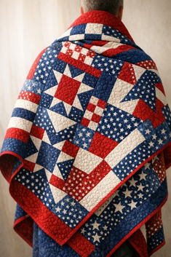
In honor of America’s 250th anniversary, the Marshfield Fair will recognize seventeen veterans during a Quilt of Valor ceremony. The mission of the Quilts of Valor Foundation is to cover Service Members and Veterans touched by war with comforting and healing Quilts of Valor.

Please join the Marshfield Fair honoring local veterans at the Quilt of Valor ceremony on Sunday, August 30, 2026, at 1:00 PM in Agricultural Hall, where Quilts of Valor will be awarded. A reception will follow.

This event would not be possible without the contributions of many supporters. Special thanks to Carin and Lisa from the Marshfield Veterans’ Services Office; Theresa Perault, Massachusetts representative for Quilts of Valor; the individuals and quilters from the following local guilds who created the Quilts of Valor: Crosstown Quilters, Friendship Quilters, Herring Run Quilt Guild, Marshfield Senior Center Quilters, Plymouth County Cranberry Quilters, Rhododendron Needlers Quilt Guild, Sachem Quilt Guild, Sanctuary Quilters, Seaside Quilters, Silver City Quilt Guild, and Edith Neil and Barbara Kelley; Co-Cordinators for QOV presentation Laurel DeCastro and Pam White; The Fisher Family and the White Family.

The Quilt of Valor® Foundation recognizes the service and sacrifice of those who are serving or have served in the Armed Forces and protect our freedoms.
DEPARTMENT 121
HANDWORK

ENTRY: August 15 & 16, 10 am–4 pm $1.00 Entry Fee per Exhibitor
MAX. 10 ITEMS PER EXHIBITOR-One item per class number
Judged on workmanship, suitability, originality. No Sewn-in Labels Permitted On Any Article.
Some entries made from kits may not be accepted
SEWING
PRIZES:$5,$4,$3
UNLESS OTHERWISE NOTED
Place the following letter of the age group the item is made for next to the class number on the entry form:
A = Adult Size
C = Children Sizes 2-12
I = Infant Sizes
H415 Suit
H416 Coat
H417 Dress
H418 Jacket
H419 Skirt
H420 Vest
H421 Hat
H422 Bib
H423 Christening set
H424 Shirt
H425 Pants/trousers/shorts
H426 Unusual - does not fit into categories listed
Household Items. Sewn
H470 Apron
H471 Bag
H472 Accessory
H473 Potholder
H474 Tablecloth
H475 Placemat
H476 Flags, banner
H477 Pillow
H478 Novelty item
H479 Unusual - does not fit into categories listed
Homemade Costumes
H480 Historical (m=men, w=woman, c=child)
H481 Party
Other ( No "Build A Bear")
H485 Doll
H486 Doll clothing
H487 Stuffed toy
H488 Sewn novelty
H489 Teddy Bear
H490 Barbie Doll Clothing
H491 Unusual - does not fit into categories listed
CROCHETING

PRIZES: $5,$4,$3
UNLESS OTHERWISE NOTED
Place the following letter of the age group the item is made for next to the class number on the entry form:
CROCHETING
A = Adult Size
C=Children Sizes 2-12
I= Infant Sizes
C260 Coat
C261 Suit
C262 Dress
C263 Bag
C264 Cape, shawl, poncho
C265 Scarf
C270 Baby set, 2 pc. or more
C271 Sweater, vest
C272 Christening set
C273 Hat ($3,$2,$1)
C274 Mittens ($3,$2,$1)
C275 Bibs ($3,$2,$1)
C276 Booties
C277 Unusual - does not fit into categories listed
Home Furnishings
C280 Afghan, large (full size or larger)
C281 Afghan, small (2 x 3 to twin size)
C282 Carriage robe
C283 Spread
C285 Pillow ($3,$2,$1)
C286 Pillowcase, runner, dresser scarf ($3, $2, $1)
C287 Doily (up to 15")($3,$2,$1)
C288 Doily (over 15 ") ($3,$2,$1)
C289 Edging or Tatting ($3,$2,$1)
C290 Unusual - does not fit into categories listed
($3,$2,$1)
Other (No "Build a Bear Items")
C291 Doll
C292 Doll clothing
C293 Stuffed toy
C294 Ornament
C295 Towel top
C296 Unusual - does not fit into categories listed
DEPARTMENT 121
KNITTING-MACHINE/HAND
MAX. 10 ITEMS PER EXHIBITOR- 1 item per class number
PRIZES: $5, $4, $3
Place letter of age group & knit type next to class #
A=Adult Size C=Children Sizes 2-12 I=Infant Sizes
CK=Cotton Knit HK-HANDKNIT MK-MACHINEKNIT
G364 Sweater- pullover
G365 Sweater - cardigan
G366 Suit
G367 Jacket
G368 Skirt
G369 Hat, bonnet
G370 Scarf
G371 Socks
G372 Shawl/cape/poncho
G373 Vest
G377 Baby set
G380 Booties
G381 Mittens
G382 Doll/doll clothes
G383 Unusual – does not fit into categories listed
Home Furnishings
G405 Afghan. large (full size or larger) ($6, $5, $3)
G406 Afghan, small (2 x 3 to twin size) ($6, $5, $3)
G407 Carriage robe ($6, $5, $3)
G408 All others not listed above
WEAVING, SPINNING
D579 Swedish weaving, small/lg
D580 Hand-woven apparel, small/lg
D581 Hand-woven item. small/lg
D582 Any article of sheepskin
Hand Spun Items put K- knitted or C-crochet on card
D583 3 assorted 2 oz. skeins yarn/2 ply
D584 1 2oz. skein single ply
D585 Apparel, large
D586 Apparel, small
D587 Sweater, knit or crochet
D588 Hat, knit or crochet
D589 Scarf, knit or crochet
D590 Mittens, knit or crochet
D591 Shawl, knit or crochet
Felt Items
D595 Apparel, large
D596 Apparel, small
D597 Novelty item
D598 Ornament
D599 Stuffed animal or doll
D600 Handbag
D601 Hand dyed wool
D602 All others not listed above

DEPARTMENT 122
ARTS & CRAFTS
QUILTING

1 ITEM PER CLASS PER EXHIBITOR
Judged on workmanship, originality, overall appearance, color, design
PRIZES: $5, $4, $3
Place the following letter of the construction method used next to the class number on the entry form:
A - hand pieced
B - hand appliquéd
C - hand embroidered/embellished
D - machine pieced
E - machine appliquéd
F - machine embroidered/embellished
X - kit – excluding pre-fused, laser cut kits
Place the following letter of the quilting techniques used next to the class number on the entry form:
G - hand quilted H - tied I – first quilt
Quilted by Machine using:
J - domestic stationary machine or sit down
K - domestic stationary embroidery machine
L – rail or track mounted machine - self driven
M - rail or track mounted machine - computer driven
N - quilted by you
O - commercial quilting /quilted by someone else
D400 Crib quilt (36x52)
D401 Twin quilt (72x90)
D402 Full size quilt (85x108)
D403 Queen or king (90x108) ($6,$5,$4)
D404 Wall hanging
D405 Group (2 or more adults and/or children)
D406 T Shirt
D407 Lap quilt or throw quilt (50x65)
D408 Miniature (less than 25"X 25”)
D409 Pre-printed panel quilts
Quilted Articles
D518 Christmas item
D519 Other holiday item (not Christmas)
D520 Wearables (jackets, vests, etc)
D521 Art quilts
D522 Pillows
D523 Table runners, placemats
D524 Purses, totes, bags
D525 Unusual - does not fit into categories listed above
D526 Comfort Quilt for donation – Quilts will be donated to local hospitals, organizations, Veterans, and charities. All sizes are accepted
Coming 2027 – “Quilting Challenge”

DEPARTMENT 122
ARTS & CRAFTS
ENTRY: August 15 & 16, 10 am–4 pm $1.00 Entry Fee Per Exhibitor
MAX. 10 ITEMS PER EXHIBITOR-One item per class number
PRIZES: $5, $4, $3 UNLESS OTHERWISE NOTED
RUGS & RELATED ITEMS
Place the appropriate letter next to the class number on the entry form:
TH = Traditional hooked L = Latched hooked
PH = Primitive hooked P = Penny
B = Braided O = Technique not listed
H527 Rug, large (over 2 x 3)
H528 Rug, small (2 x 3 & under)
H529 Chair pad
H530 Bench pad
H531 Pillow
H532 Small wallhanging
H533 Large wallhanging
H534 Table runner
H535 Unusual – does not fit into categories listed
NEEDLEWORK
Place the appropriate letter below next to the class number on the entry form:
N = Needlepoint CS = Cross Stitch
E = Embroidery MS = Mixed Media
C= Crewel
( Mark "L" linen / "D" dark)
K540 Wall hanging (ready to hang)
K541 Pillow
K542 Picture - small framed (under 12")*
K543 Picture - large framed (12" & above)*
K544 Holiday
K545 Clothing
K549 Unusual - does not fit into categories listed
*Pictures - framed, ready to hang.
CRAFTS
ALL ITEMS SMALLER THAN 4" MUST BE
MOUNTED ON A FIRM BASE AT LEAST 3 " X 5”
No Store-Bought Puzzles.
One entry per class number.
Holiday Crafts
E575 Christmas stocking
E576 Christmas ornament
E577 Christmas tree skirt
E578 Non Christmas item i.e. Halloween
E579 Unusual - does not fit into categories listed
Padded Items
E580 Album
E581 Padded boxes
E582 Unusual - does not fit into categories listed
Plaster of Paris*
E590 Cast
E591 Hand mold
Clay Articles*
E595 Person
E596 Animal group
E597 Animal single
E598 Unusual - does not fit into categories listed Jewelry*
E604 Bracelet
E605 Earrings
E606 Necklace
E607 All other not listed above
Miniatures * (mounted)
E735 Animal
E736 Food (dollhouse)
E737 Furniture
E738 Miniature room
E739 Single item scale 1" to 1’
E740 Single item not to scale
E741 Wood house
E742 Unusual - does not fit into categories listed
Metalwork*
E745 Large
E746 Small
E749 Unusual - does not fit into categories listed
Handpainted or Stenciled Articles*
(place H or S on cards)
E750 Birdhouse
E751 Container
E752 Metal
E753 Picture or mirror frame
E754 Rock
E755 Shelf item
E756 Sign
E757 Slate
E758 Toy
E759 Wallhanging
E760 Wood panel
E761 Wooden, large
E762 Wooden, small
E763 Unusual - does not fit into categories listed
*Items smaller than 4" must be mounted on a
firm base at least 3" x 5”.

ENTRY: August 15 & 16, 10 am–4 pm $1.00 Entry Fee Per Exhibitor
MAX. 10 ITEMS PER EXHIBITOR-One item per class number
PRIZES: $5, $4, $3 UNLESS OTHERWISE NOTED
DEPARTMENT 122
ARTS & CRAFTS
Miscellaneous Crafts
E770 Batik
E771 Blown glass
E772 Candle
E773 Chair caning
E774 Chair rush work
E775 Decoupage
E776 Games
E777 Gimp
E778 Hair accessory
E800 Lamps
E801 Lampshade
E802 Leatherwork
E803 Macramé
E804 Mask
E805 Metal
E806 Mobile
E808 Paper mache
E809 Polymer clay
E810 Porcelain doll
E811 Puppet
E813 Shell work
E814 Specialty doll
E815 Soap homemade
E816 Stained glass
E817 Stamp art
E818 String art
E819 T shirt, sweatshirt decorated
E820 Toy
E821 Item from recycled material
E823 Wind chimes
E824 Wood burning
E826 Book
E827 Mosaic - original design
E828 Unusual - does not fit into categories listed
Basketry
G620 Coiled
G621 Combination of materials
G622 Miniature
G623 Nantucket, small
G624 Nantucket, medium
G625 Nantucket, large
G626 Original design
G627 Ribbed
G628 Round reed
G629 Splint
G630 Unusual - does not fit into categories listed
Pottery/Ceramics
Place the appropriate letter below next to the class number on the entry form:
P= Pottery C= Ceramic
G650 Animals, group
G651 Animals, single
G652 Basket
G653 Bowl
G654 Casserole
G655 Human figure, group
G656 Human figure, single
G657 Mask
G658 Mug
G659 Planter
G660 Plate/platter
G661 Pitcher
G662 Pitcher and bowl set
G663 Vase
G664 Unusual - does not fit into categories listed
Woodworking
Must be built by exhibitor. Items exceeding 3’ in any
direction will not be accepted due to space constraints.
A699 Bench
A700 Bird feeder
A701 Bird house
A702 Building replica
A703 Chair
A704 Intarsia
A705 Large item
A706 Lawn Item
A707 Novelty
A708 Shelf
A709 Sign
A710 Small table or shelf item
A711 Stool
A712 Table
A713 Toy
A714 Turned Item
A715 Unusual - does not fit into categories listed
Woodburning
A717 Plaque
A718 Other

DEPARTMENT 122
ARTS & CRAFTS

ENTRY: August 15 & 16, 10 am–4 pm $1.00 Entry Fee Per Exhibitor
MAX. 10 ITEMS PER EXHIBITOR-One item per class number
PRIZES: $5, $4, $3

Bird Carving **Hand Carved-No Chainsaw Carvings
B720 Full size realistic
B721 Miniature realistic
B722 Interpretive
B725 All others not listed above
Carving** Hand Carved Only
B727 Animal
B729 Chip
B730 Figures
B731 Picture, large
B732 Picture, small
B733 Plaque
B734 Sign
B735 Unusual - does not fit into categories listed

**See page 14 for painted wooden items not
hand built.
**Items smaller than 4" must be mounted on
a firm base at least 3" x 5".
Juniors Only
Models-Metal/Wood/Plastic*
*Models are extremely fragile.
Special care is taken but there are no guarantees.
Make sure all parts are securely glued.
Items 4" or smaller must be mounted on a firm
base at least 3" x 5".
F790 Airplane
F791 Animal
F792 Boat
F793 Car, customized
F794 Car, standard
F795 Collection on a sturdy base(12"x 12")
F796 Rocket, missile
F797 RV
F830 Tank
F831 Train
F832 Truck
F833 Unusual - does not fit into categories listed
F845 Dioramas (in a box, firmly glued)
ARTWORK
CONDITIONS OF ENTRY:
- All artwork must be framed and ready to
hang with picture wire attached SECURELY.
- NO TAPED-ON HANGERS! or metal sawtooth-type
hangers.
- Original art only - No copies of existing art.
- Must have been completed between 9/25-9/26
J100 Acrylic portrait
J101 Acrylic landscape
J102 Acrylic still life
J103 Acrylic waterscape
J104 Acrylic animal
J105 Acrylic abstract
J106 Charcoal
J107 Collage
J108 Colored pencil
J109 Computer generated
J110 Crayon, pastel or wax
J111 Felt marker
J112 Ink resist
J113 Linoleum or wood print
J114 Mixed media
J115 Oil portrait
J116 Oil landscape
J117 Oil still life
J118 Oil waterscape
J119 Oil animal
J120 Oil abstract
J121 Pastel
J122 Pen and ink
J123 Pencil
J124 Poster paint
J125 Scratch board
J126 Tinsel
J127 Watercolor portrait
J128 Watercolor landscape
J129 Watercolor still life
J130 Watercolor waterscape
J131 Watercolor animal
J132 Watercolor abstract
J133 Unusual – does not fit into categories listed

COUNTRY ARTS ENTRY FORM

Exhibitor No.___________________
ARTS & CRAFTS ENTRIES
$1.00 Entry Fee Per Exhibitor
MAXIMUM 10 ITEMS
Name__________________________________________ Email ____________________________________
Street ________________________________________________________________________________________
Town ________________________________ State ___________ Zip ______________ Phone _________________
Check Group : Adult Special Needs Jr.– 13 (put age)_____ Jr. 14-18 (put age)_______
Dept | Class | Item Description – PLEASE BE DESCRIPTIVE | Pg #
122 | D400 | Quilt- twin - red, white, blue -stars - red backing | 14
-THIS RECEIPT NECESSARY TO COLLECT ARTICLES- Pick up is on the Tuesday after the close of the fair from 2 - 6 pm.
NAME__________________________________________________________________ No. of Articles________________
ADDRESS _________________________________________________________________________________________________
Committee Member Signature _________________________________________________________________________________
Pick up is on the Tuesday after the close of the fair from 2 - 6 pm.
DEPARTMENT 124
PHOTOGRAPHY


ENTRY FEE $5.00 PER PHOTOGRAPH
10 Picture Entry Limit per Photographer
ONLY ONE PHOTOGRAPH PER CATEGORY ALLOWED
It can be either color or black and white.
Judged on content, composition, light, originality, presentation and relevance to the class entered.

ENTRY: Saturday, August 15, 10 – 4 pm
Sunday, August 16, 10 – 4 pm
REMOVAL: Tuesday, September 1, 2 – 6 pm

LOCATION: Exhibit Barn (Building E)
ENTRY FEE: $5.00 per photograph
10 picture entry limit
* * *CONDITIONS OF ENTRY ***
- Photographs must be at least 5" x 7" FRAMED and NO LARGER than 11” x 14” matted and framed. Anything smaller or larger will not be accepted.
- Photographs must be matted and framed. Frames must be made of wood, metal, or plastic only, be enclosed on all four sides with no stands on the back. NO BOX FRAMES OR CLIP FRAMES.
- Photographs must be ready to hang with PICTURE WIRE ONLY. Picture wire must be taut and securely fastened to the back of the frame approximately 1/3 of the way down from the top.
- Photos must have been taken within the past year, be original and been taken by the exhibitor.
- Exhibitor's name and address must be visible on the back of the photograph.
- One entry per exhibitor per class and category, please!
- Absolutely NO exceptions to these conditions.
- There is a 10 picture entry limit per photographer.
- NOTE: Entry fees are $5.00 PER PHOTOGRAPH

If your photograph does not meet these
requirements, it will not be accepted.
NO EXCEPTIONS
Only one photograph per category allowed either color or black and white.

Categories
Adult Junior
Color Color
Black & White Black & White
PRIZES:$25, $15, $10
UNLESS OTHERWISE NOTED
Class #
F120 Wildlife - any animal in nature including bird, insects, reptiles, mammals
F121 Pets - any domesticated animal in any setting or circumstances
F122 Farming & Gardening - anything related to the landscape of farms and gardens including farm animals (horses, cows, chickens etc.)
F123 Nature - pictures of the natural world untouched by humans including landscapes, abstracts, trees, flowers, etc.
F124 Portraits - pictures of adults and children, candid or posed, individual or groups, where human interest is central to the story told by the picture
F125 Scenic - any outdoor scene, landscape or cityscape where there is a strong emphasis on light and composition
F126 Pictorial - everyday ordinary events, places, people or things captured with a unique, imaginative perspective
F127 Marshfield Fair 2025 - an image from last year's fair that strongly embodies the spirit of the Marshfield Fair. All photographs entered in the Marshfield Fair class will be considered for use by the Marshfield Fair for advertising and publicity purposes.
F128 Travel -a picture taken while on a trip
F129 Phone - a picture taken with a Smartphone
F130 Holiday- any holiday
F131 Predominate Color - photo with a main color
F132 America the Beautiful in your eyes
Use Photography Entry Form Only (page 20) Entries accepted on entry days ONLY

PHOTOGRAPHY ENTRY FORM

Exhibitor No.______________________

Enter in person on August 15 and August 16, 10 am – 4 pm
Entry Fee per Photograph - $5.00
10 pictures entry limit per photographer – One entry per category only
Name _______________________________________________ Email ____________________________________
Address _______________________________________________________________________________________
Town _________________________________ State ___________ Zip ___________ Phone ___________________
Check Group : Adult Jr.– 13 (put age)_______ Jr. 14-18 (put age)_______

 | Dept | Class | Item Description – PLEASE BE DESCRIPTIVE
 | 124 | F123 | Nature – color photo –ocean/beach scene with blue matting
1. | 124
2. | 124
3. | 124
4. | 124
5. | 124
6. | 124
7. | 124
8. | 124
9. | 124
10. | 124
-THIS RECEIPT NECESSARY TO COLLECT ARTICLES- Pick up on Tuesday after the fair, from 2 - 6 pm -
Name __________________________________________________________________________ No. of Articles ______________

